Name-Ujjawal Mandhani
Batch-F6
Enroll No.-9918103237
OSS Lab-8

Question 1:Write a Python program to create a 2-D array with ones on the diagonal and zeros
elsewhere. Now convert the NumPy array to a SciPy sparse matrix in CSR format

import numpy as np
from scipy import sparse
eye = np.eye(4)
print("NumPy array:\n", eye)
sparse_matrix = sparse.csr_matrix(eye)
print("\nSciPy sparse CSR matrix:\n", sparse_matrix)

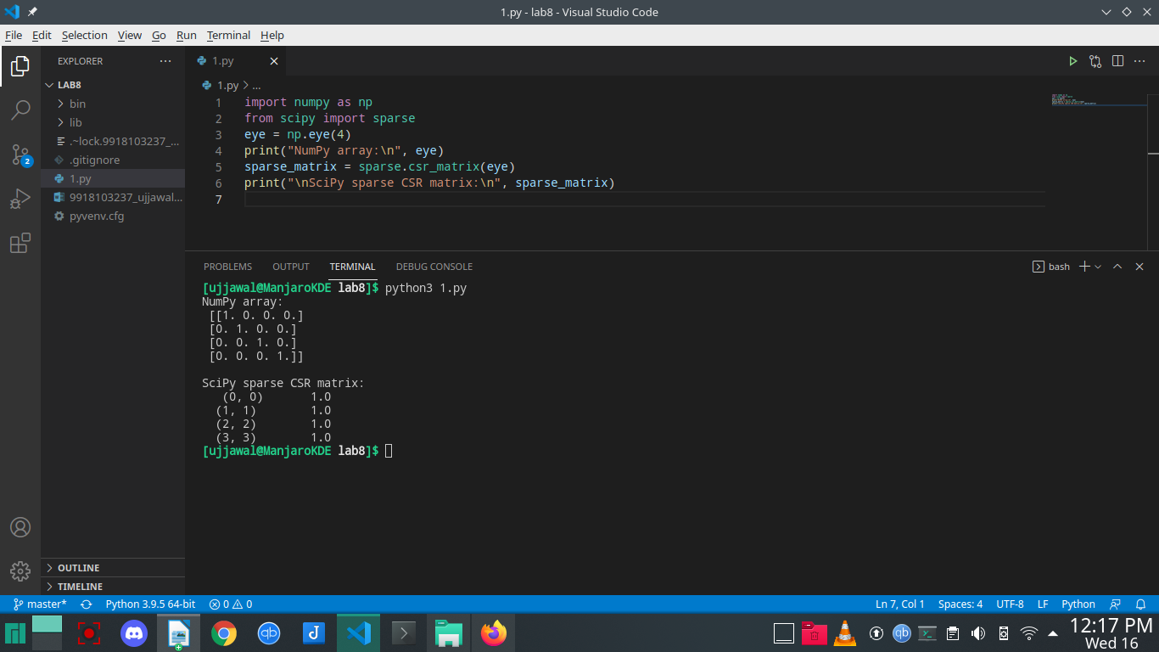
Question 2:Write a Python program using SciPy library to view basic statistical details like
percentile, mean, std etc. of iris data.

import pandas as pd
from sklearn.datasets import load_iris
iris = load_iris()

print(iris)

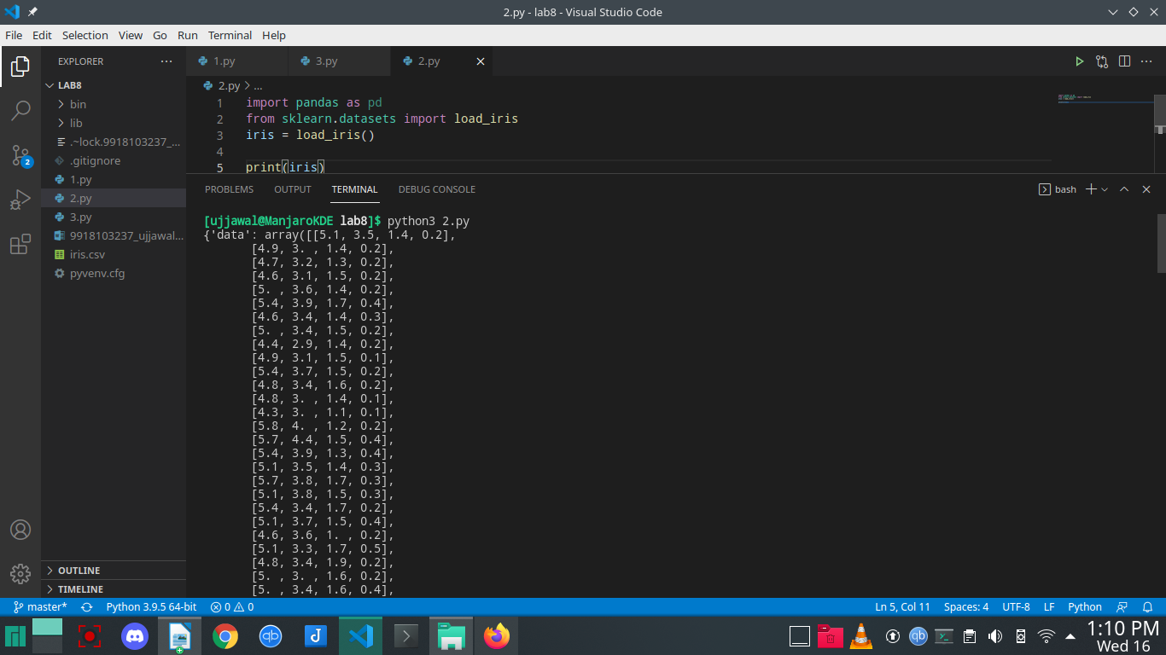
Question 3:Write a Python program using Scikit-learn to split the iris dataset into 70% train data and 30% test data. Out of total 150 records, the training set will contain 120 records and the test set contains 30 of those records. Print both datasets.

from sklearn.model_selection import train_test_split
from sklearn.datasets import load_iris
iris = load_iris()
x, y = iris.data, iris.target
x_train, x_test, y_train, y_test = train_test_split(
x, y, test_size=0.3, random_state=123)
print("\n70% train data:")
print(x_train)
print(y_train)
print("\n30% test data:")
print(x_test)
print(y_test)

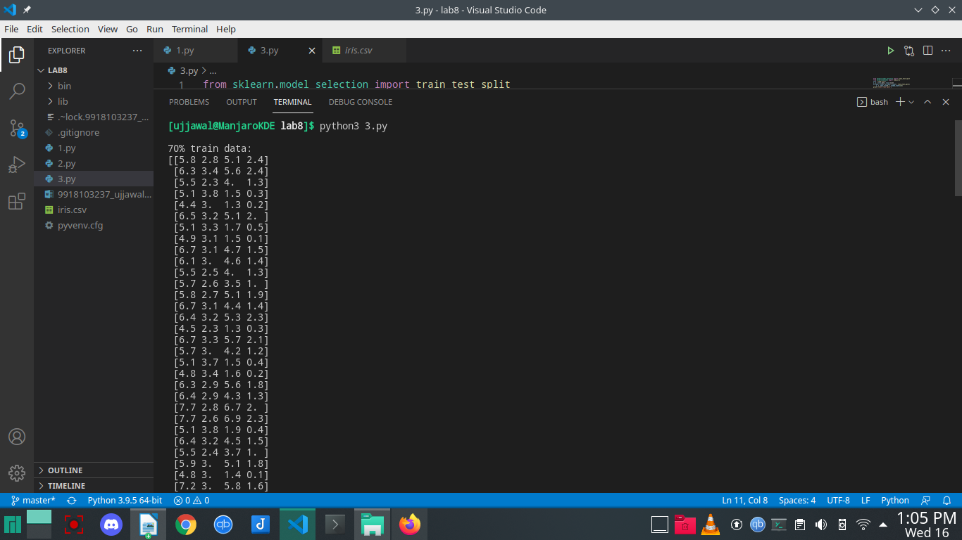
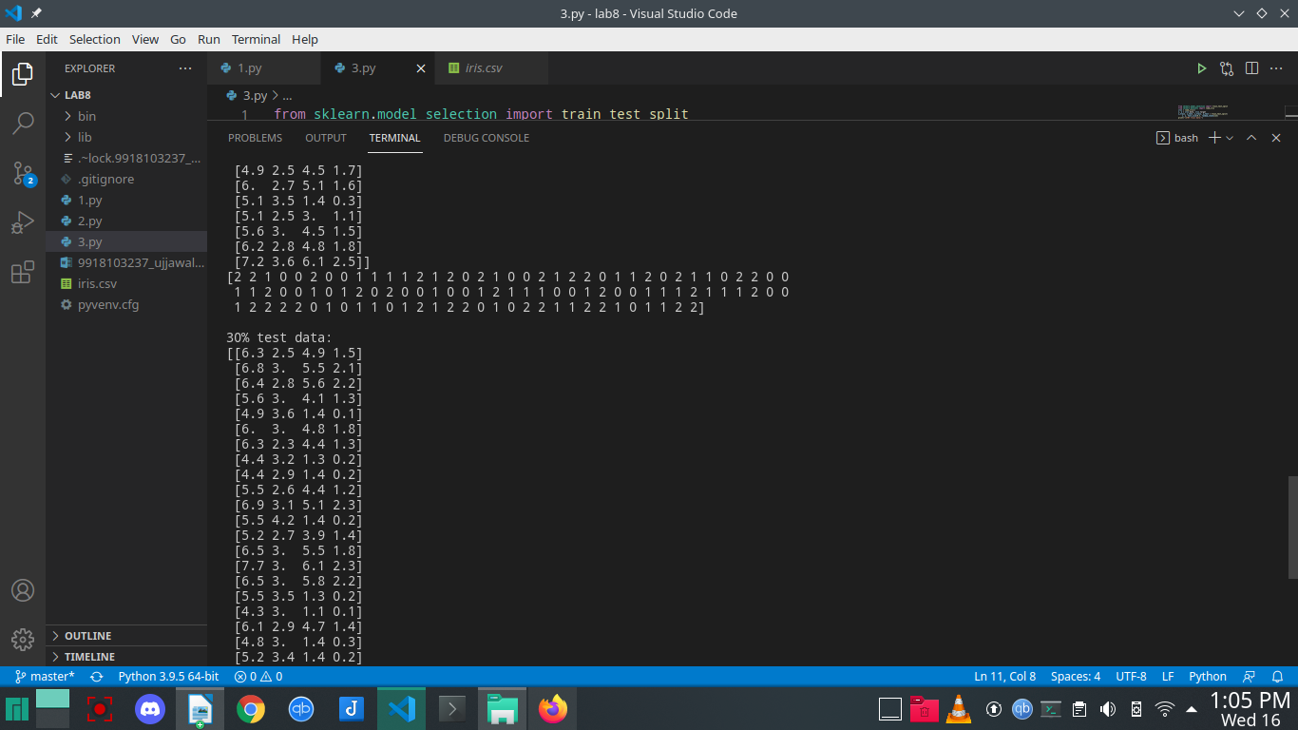
Question 4: Write a Python program using Scikit-learn to split the iris dataset into 80% train data and 20% test data. Out of total 150 records, the training set will contain 120 records and the test set contains 30 of those records. Train or fit the data into the model and using the K Nearest Neighbor Algorithm and create a plot of k values vs accuracy. Similarly show the results for other classification techniques as well.

import pandas as pd
from sklearn.model_selection import train_test_split
from sklearn.neighbors import KNeighborsClassifier
from sklearn.datasets import load_iris
iris = load_iris()
x, y = iris.data, iris.target
x_train, x_test, y_train, y_test = train_test_split(
x, y, test_size=0.2)
knn = KNeighborsClassifier(n_neighbors=5)
knn.fit(x_train, y_train)
print("Response for test dataset:")
y_pred = knn.predict(x_test)
print(y_pred)

'''

"0": setosa
"1": versicolor
"2": virginica

'''

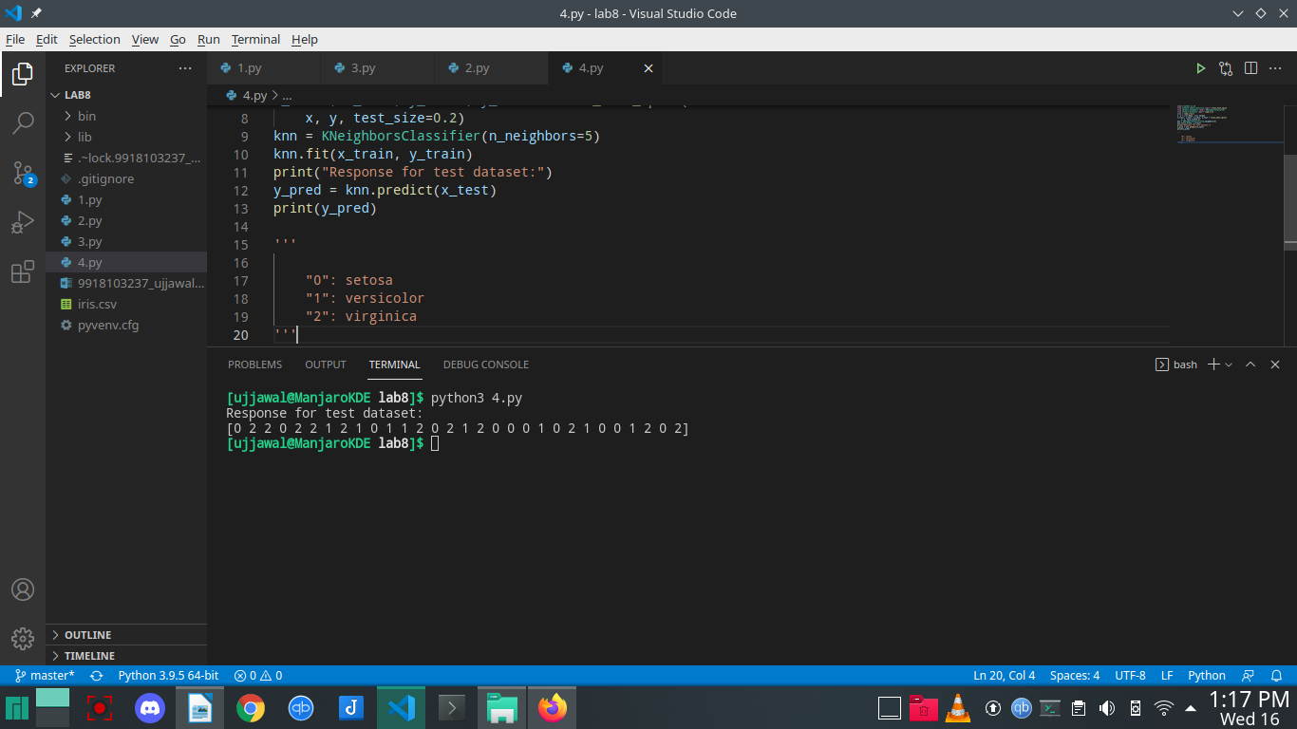
Question 5:In statistical modeling, regression analysis is a set of statistical processes for estimating
the relationships among variables. It includes many techniques for modeling and
analyzing several variables, when the focus is on the relationship between a dependent
variable and one or more independent variables (or &#39;predictors&#39;). Write a Python program
to get the accuracy of the Logistic Regression and Linear Regression on Boston Housing
Dataset. You can load the dataset as:

import pandas as pd
import numpy as np
from sklearn.datasets import load_boston
from sklearn.model_selection import train_test_split
from sklearn.linear_model import LinearRegression
from sklearn.metrics import mean_squared_error
from sklearn.metrics import r2_score
from sklearn.linear_model import LogisticRegression

boston_dataset = load_boston()
X, Y = boston_dataset.data, boston_dataset.target

X_train, X_test, Y_train, Y_test = train_test_split(
X, Y, test_size=0.2, random_state=42)
lin_model = LinearRegression()
lin_model.fit(X_train, Y_train)

y_train_predict = lin_model.predict(X_train)
rmse = (np.sqrt(mean_squared_error(Y_train, y_train_predict)))
r2 = r2_score(Y_train, y_train_predict)

print("The model performance for training set For Linear")
print("--------------------------------------")
print('RMSE is {}'.format(rmse))
print('R2 score is {}'.format(r2))
print("\n")
y_test_predict = lin_model.predict(X_test)
rmse = (np.sqrt(mean_squared_error(Y_test, y_test_predict)))
r2 = r2_score(Y_test, y_test_predict)

print("The model performance for testing set for linear")
print("--------------------------------------")
print('RMSE is {}'.format(rmse))
print('R2 score is {}'.format(r2))

